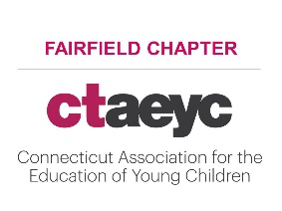
Chapter Meeting Dates – 2020-2021

Month/Date | Day
September 17– Zoom | Thursday
October 20 – Zoom | Tuesday
November 18 – Zoom | Wednesday
December | No Meeting
January 14 – RM TBD | Thursday
February 16 – RM TBD | Tuesday
March 24 – RM TBD | Wednesday
April 15 – RM TBD | Thursday
May 25 – RM TBD | Tuesday
June 23 – RM TBD | Wednesday

*In person meetings are at Norwalk Community College @ 4:30. We will determine when to resume in person meetings based on guidance from Governor Lamont pertaining to COVID-19 health and safety mandates.
*For new members and attendees - Please email us at GFRC203@gmail.com ahead of the meeting so we can send you the link or check the CTAEYC Facebook page around the time of the date. All cancellations will be posted on Facebook.

